🧪 📁 Linux Lab: Change File Ownership
🎯 Goal
Learn how to:
- View file ownership
- Change file owner
- Change group ownership
- Verify changes
This is a common Linux Admin and DevOps task.

⚙️ Step 1: Create a Test File
touch project.txt
Verify:
ls -l project.txt
Example output:
-rw-r--r-- 1 kali kali 0 Aug 18 project.txt
Here:
Owner = kali
Group = kali
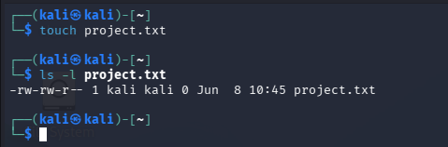

⚙️ Step 2: Create User & Group
Create user:
sudo useradd -m john
Create group:
sudo groupadd dev
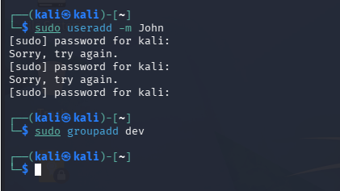

⚙️ Step 3: Change File Owner
sudo chown john project.txt
Verify:
ls -l project.txt
Output:
-rw-r--r-- 1 john kali 0 Aug 18 project.txt
✅ Owner changed
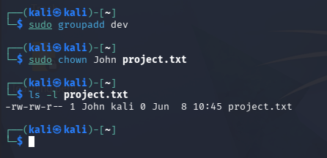

⚙️ Step 4: Change Group Ownership
sudo chown :dev project.txt
Verify:
ls -l project.txt
Output:
-rw-r--r-- 1 john dev 0 Aug 18 project.txt
✅ Group changed
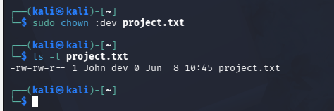

⚙️ Step 5: Change Owner & Group Together
sudo chown john:dev project.txt
Verify:
ls -l project.txt
Output:
-rw-r--r-- 1 john dev 0 Aug 18 project.txt

🧠 Easy Memory Trick
chown
change owner

Syntax
Change owner:
sudo chown user file
Change group:
sudo chown :group file
Change both:
sudo chown user:group file

🌍 Real-World Example
A web application file belongs to:
root root
But Apache runs as:
www-data
Application cannot access the file.
Fix:
sudo chown www-data:www-data app.conf
Problem solved ✅

🎤 Interview Answer
"I used the chown command to modify file ownership and group ownership, ensuring proper access control for users, applications, and services."

🚀 Bonus Challenge
Create:
cloud.txt
Then:
- Create user devops
- Create group cloud
- Assign ownership:
Owner = devops
Group = cloud

🌐 Scenario 1: Web Server Cannot Access Website Files
Problem
Apache/Nginx cannot read website files.
403 Forbidden
Permission Denied
Check:
ls -l /var/www/html
Output:
root root index.html
But Apache runs as:
www-data
Fix
sudo chown -R www-data:www-data /var/www/html

📂 Scenario 2: Shared Team Folder
Problem
Developers and Operations teams need access to same folder.
Create group:
sudo groupadd project
Assign ownership:
sudo chown -R john:project /app
Now multiple users can collaborate.

🚀 Scenario 3: Application Deployment
Problem
After deployment:
Application cannot write logs
Check:
ls -l /opt/app/logs
Output:
root root
Application runs as:
appuser
Fix
sudo chown -R appuser:appuser /opt/app/logs

💾 Scenario 4: Backup Restore
Problem
Files restored from backup belong to:
root root
Users cannot access them.
Fix
sudo chown -R finance:finance /backup/finance

☁️ Scenario 5: Jenkins Pipeline Failure
Problem
Jenkins cannot write build artifacts.
Error:
Permission denied
Fix
sudo chown -R jenkins:jenkins /var/lib/jenkins
Very common DevOps issue.

🐳 Scenario 6: Docker Volume Permission Issue
Problem
Container cannot write data.
Check:
ls -l /data
Owner:
root root
Container user:
1001
Fix
sudo chown -R 1001:1001 /data

🔒 Scenario 7: SSH Key Permissions
Problem
SSH login fails.
Check:
ls -l ~/.ssh
Wrong owner:
root root
Fix
sudo chown -R user:user ~/.ssh

📊 Scenario 8: Log Monitoring Tools
Problem
Splunk/Filebeat cannot read logs.
Log file:
root root
Monitoring agent:
splunk
Fix
sudo chown splunk:splunk app.log

🎤 Interview Answer
"In production, I use chown when applications, web servers, monitoring tools, Jenkins pipelines, Docker containers, or users cannot access files due to incorrect ownership. Changing ownership ensures the correct service account has the required permissions."

🚀 Hands-On Production Lab
A very realistic lab for LinkedIn/interviews:
- Create user appuser
- Create file application.log
- Change ownership to root
- Simulate application access issue
- Fix using:
sudo chown appuser:appuser application.log
This mirrors a real production troubleshooting scenario and looks great on a resume and in interviews.

